**Collections**

Index:

1. Arrays (1 -27)

* Memory allocations
* Different methods for Arrays Operations - <https://ioflood.com/blog/java-array-methods/>
* Progarms - ? find the second highest value [1,2,3,4,5,6,7,8,9]?

1. Why do we need collections framework?(28-

* Overview about Collections Framework

1. List(Arraylist,Vector), Set, Queue (internal working)
2. Map internal working
3. Java8 HashMap improvements
4. Why Generic and how to use?
5. Collections, CollectionsUtils,
6. ConcurrentModificationsException – Iterator vs ListIterator
7. Comparator vs Comparable

**1. Arrays:**

Reference Link : <https://medium.com/edureka/java-array-tutorial-50299ef85e5>

**Definition:**

In Java, array is an object of a dynamically generated class. Java array inherits the Object class, and implements the Serializable as well as Cloneable interfaces. We can store primitive values or objects in an array in Java. Like C/C++, we can also create single dimensional or multidimensional arrays in Java.

Arrays in Java are a fundamental data structure used to store collections of elements, typically of the same type. They are objects in Java, which means they are created on the heap, and can hold primitives (like int , char ) or objects (like String , Integer ).

Java is a general-purpose, concurrent, object-oriented, class-based, and the runtime environment(JRE). Through this blog on Java Array, I will explain you the concepts of Arrays in Java and how single & multi-dimensional arrays work.

**How exactly does indexing works in Arrays?**

First, let’s understand arrays, It is a collection of items stored at contiguous memory locations. The basic idea is to store multiple items of the same type together which can be accessed by index/key (a number).

The contiguous memory of declared size is allocated on heap/stack and then the address of the element is calculated mathematically during run-time as:-

|  |
| --- |
| element address = (base address) + (element index * size of a single element) |

**Base address**: It is the address of the element at the index 0 or the location of the first element of the array in the memory. The compiler knows this address as the memory location of the array.

**Element index:** It is the sequential number (index/key) assigned to the element where the first element of the array is assigned 0. It can also be defined as the number of elements prior to that particular element in the array.

**Size of a single element:** Elements in the array need to be of the same data type or object. The size of the single element is the number of bytes required in memory to store a single element of that kind.

For example:

* **Int** type requires 4-bytes (32-bit)
* **char** type requires a 1-byte (8-bit)
* **long** type requires 8-byte (64-bit) etc.

**Example of above implementation:**

|  |
| --- |
| **int arr[6] = {3, 4, 7, 9, 7, 1}**  address of arr[0] (base address) = 0 x 61fe00  address of arr[3] (element address) = (base address) + (element index * size of a single element)  0 x 61fe00 + ( 3 * 4) = 0 x 61fe0c  Here, size of a single element is 4-bytes as it is int- type array.  **long long arr[6]={100, 12, 123, 899,124, 849}**  address of arr[0] (base address) = 0x61fdf0  address of arr[3] (element address) = (base address) + (element index * size of a single element)  0x61fdf0 + ( 3 * 8) = 0x61fe08  Here, size of a single element is 8-bytes as it is long – type array.  **Note**:  Here addresses are of Hexadecimal form.  x- means nth term values – 0th address of the value |
| **Note**: arr[9] – Then it will calculate the actual memory location of 9th index value using above formula and it will jump directly into that address and fetch the value. That is the reason Arrays are much preferable during searching process.  Reference Link: <https://javachallengers.com/array-data-structure/#:~:text=Simply%20put%2C%20an%20array%20is,a%20reference%20for%20this%20object>. |

**Array Data Structure with Java**

* The array data structure is probably the most used in every application. If not directly used it’s indirectly used with ArrayList, ArrayDeque, Vector, and other classes.
* Simply put, an array is a data structure that stores multiple variables into it so that there is no need to create many variables with different names.
* Arrays in Java are always an object, therefore, they will occupy space in the memory heap and it will create a reference for this object.

**Array Memory Allocation**

* The array is stored in the memory RAM and takes up space back to back. Most memory RAM stores 1 byte (8 bits) in each space. In Java, each primitive int number occupies 4 bytes in memory. Therefore, let’s how this would work in the following memory model if we create an array with 5 int elements:

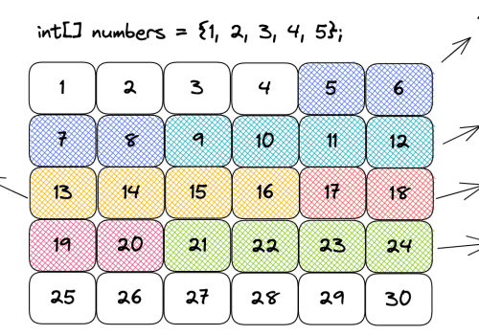

* As you can see in the above diagram, when we are creating an array we must pass the type of the elements and size from it. That’s because when creating the array the memory allocation has to be back to back.
* That’s the reason why we can very quickly access an element from an array. Since we know where the array starts, in the case of the diagram above it’s in the memory address 5, the compiler makes a simple calculation.
* Considering the index we pass to the array, the size, and the type of the element, we can easily calculate where the element is present in memory. To get the second element from the array, for example, we would add 4 bytes to the first element index and we would know where the second element is allocated. For this reason, to access an element in an array the time complexity will be **always O(1).**
* To change an element in the array is also constant **time O(1).** That’s because we can quickly access the variable index and assign a new value to it.
* To create an array the time complexity **is O(n) because when creating it**, we will define the type and size of the array and the **required space in memory will be allocated**.

**Static Arrays**

* As the name suggests, a static array is an array that can’t be changed. We need to pass the type and size of the array and after that, we can’t change the type or size of the array.
* Let’s see in the following code how to create a static array with the int type and show all the elements:

|  |
| --- |
| int[] array = **{1, 2, 3, 4, 5}; // Create an array O(n)**  for (int i = 0; i < array.length; i++) {  System.out.print(array[i] + " ");  }  Output:  1 2 3 4 5 |

* Notice in the code above that we create an array of int values. Once it’s created we can’t change either the type or the size of the array, that’s what makes it static.
* Then we access each element of the array by index and show the values that will be 0 because those are the default values for primitive int in Java.

**Insert an Element in the Middle of the Array**

* To insert an element in the middle of the array it will be necessary to shift the elements. Therefore, the time complexity will be O(n).
* Let’s imagine we want to put 3 in the middle of 2 and 4 in the following array: { 1, 2, 4, 5 }. To do that, we will have to first create a new array with the size of 5.
* Then, it will be necessary to move elements 4 and 5 to one position ahead. Once this is done we can access index 2 and insert element 3.

**Dynamic Arrays**

* There are classes in Java that make use of a dynamic array such as ArrayList, Vector, and others. When we create an ArrayList, we have a static array under the hood that starts as empty but after adding the first element the size goes to 10. Then it doubles every time it’s needed as you can see in the following code of the JVM:

|  |
| --- |
| public class ArrayList<E> extends AbstractList<E>  implements List<E>, RandomAccess, Cloneable, java.io.Serializable  {  private static final int DEFAULT_CAPACITY = 10;  transient Object[] elementData;  private int size;    private static final Object[] DEFAULTCAPACITY_EMPTY_ELEMENTDATA = {};    public ArrayList() {  this.elementData = DEFAULTCAPACITY_EMPTY_ELEMENTDATA;  }    // This is the method that will double the array whenever it's needed  private Object[] grow(int minCapacity) {  int oldCapacity = elementData.length;  if (oldCapacity > 0 || elementData != DEFAULTCAPACITY_EMPTY_ELEMENTDATA) {  int newCapacity = ArraysSupport.newLength(oldCapacity,  minCapacity - oldCapacity, /* minimum growth */  oldCapacity &gt;&gt; 1 /* preferred growth */);  return elementData = Arrays.copyOf(elementData, newCapacity);  } else {  return elementData = new Object[Math.max(DEFAULT_CAPACITY, minCapacity)];  }  }    // Omitted other methods...    } |

* The elementData variable is the one that will store the data behind the scenes for the ArrayList. Therefore, notice that the dynamic array actually manipulates a static array to behave as dynamic.
* When adding an element to an ArrayList, it will check if the size is greater than 10 and if that is true the time complexity will be O(n). That happens because since the array was created with the size of 10, it’s necessary to create a new array with the size of 20 copying all the elements into the new one. To do so, we need to traverse the whole array and copy element by element. Then we add the 11th element to the array.
* When the array behind the scenes is created with the size of 20 then whenever we add an element we will have the time complexity of O(1). Notice that the vast majority of the time when adding an element to a dynamic array will be pretty fast, it will be O(1). Only on the edge-case scenarios when the array size needs to be doubled the time complexity will be O(n). This is also called amortized complexity.

**Summary**

* An array is allocated in memory from back to back.
* Accessing an array by index has the time complexity of O(1), it’s pretty fast.
* Static array is the array that is created with a size and a type pre-defined.
* Dynamic array is an adaptation of the static array that automatically resizes it when necessary.
* A dynamic array will double its size when necessary.
* Adding an element to a dynamic array will be mostly O(1) because there will be space more often.
* When adding an element to a dynamic array exceeds the size of the static array under the hood, it will be necessary to create a new array, copy the elements from the existing array, then add the new element. Therefore, the time complexity will be O(n).
* Adding an element in the middle of the array will have the time complexity of O(n). That’s because it will be necessary to shift all the elements from the right side to one position on the right. Only then we will be able to insert the element by index.
* To remove the first element from the array, it will be necessary to shift all the elements from the right to the left. Therefore, the time complexity is O(n).
* To remove an element from the array in the last position takes O(1) complexity. That’s because we only need to remove the last value and we have direct access to it.

**What are Java Arrays?**

* Arrays in Java are homogeneous data structures implemented in Java as objects.
* Arrays store one or more values of a specific data type and provide indexed access to store the same.
* A specific element in an array is accessed by its index.
* Arrays offer a convenient means of grouping related information.

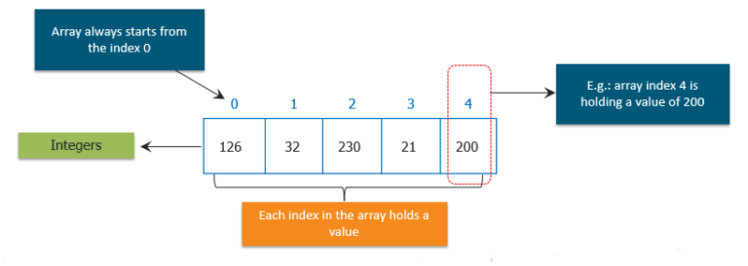Obtaining an array is a two-step process.

* First, you must declare a variable of the desired array type
* Second, you must allocate the memory that will hold the array, using new, and assign it to the array variable

So, let us see how can we declare arrays in different ways.**General Form of Java Array Initialization**

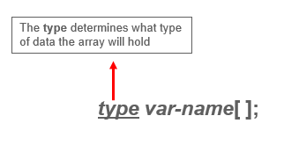

Example:- int month_days[];

**General Form of Java Array Initialization**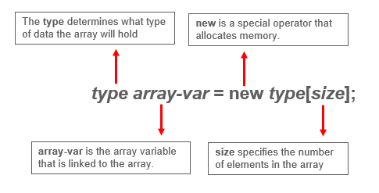

**Example:**

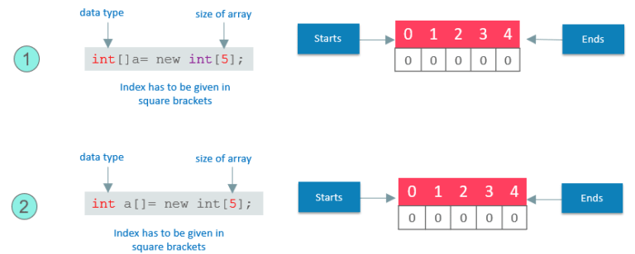

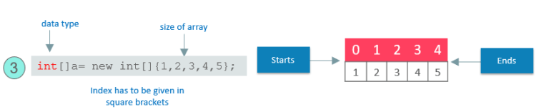

* **Static Arrays** will give arrays size with initialization values.
* Arrays can be initialized when they are declared.
* The array will automatically be created large enough to hold the number of elements you specify in the array initializer.
* There is no need to use new.
* Now, let us see how we can implement this.

General Form of Java Array Initialization: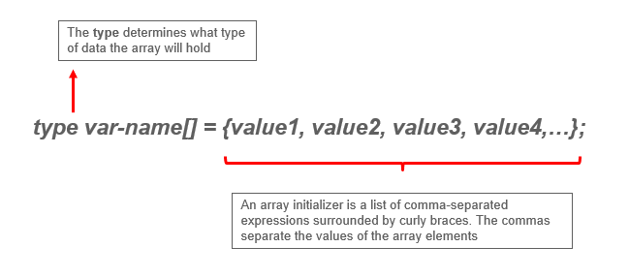

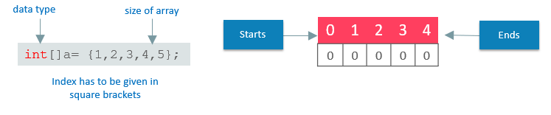

The following code creates an initialized array of integers:

|  |
| --- |
| class MyArray{    public static voide main(String args[]){    int month_days[ ] = {31,28,31,30,31,30,31,30,31,30,31};    System.out.println("April has " + month+days[3] + "days.");    }    } |

* It will only be fair if I explain how you can access elements in a Java Array.
* Accessing a Specific Element in a Java Array
* In arrays, we can access the specific element by its index within square brackets.

**Example:**

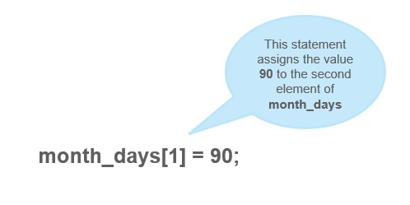

Putting together all the pieces:

|  |
| --- |
| public static void main(String args[]) {  int month_days[];  month_days = new int[12];  month_days[0] = 31;  month_days[1] = 28;  month_days[2] = 31;  month_days[3] = 30;  month_days[4] = 31;  month_days[5] = 30;  month_days[6] = 31;  month_days[8] = 30;  month_days[9] = 31;  month_days[10] = 30;  month_days[11] = 31;  System.out.println("April has " + month_days[3] + " days.");  }  } |

* So, this was all about the arrays and its declaration and how single dimension arrays can be used.
* What if I tell you, there can be an array inside an array. I know it sounds a bit complex, but don’t worry, I know how to make it easy for you.

**Java Multidimensional Array:**

* Multidimensional arrays are arrays of arrays.
* Declaring Multidimensional Array
* To declare it, we have to specify each additional index using another set of square brackets.

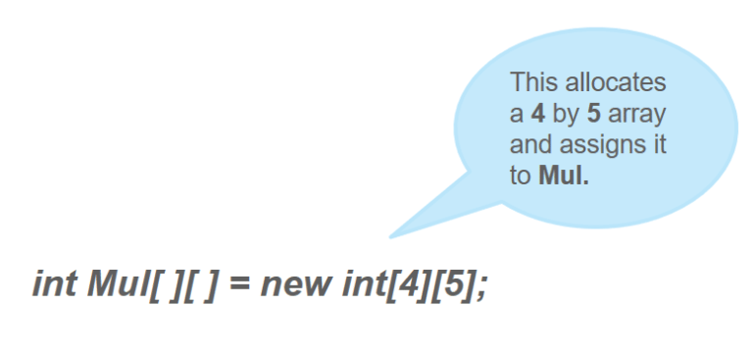

Conceptually, the array declared above would be represented as shown in the figure:

Let us now Demonstrate Multidimensional Array.

The following program, numbers each element in the array from left to right, top to bottom, and then displays these values:  
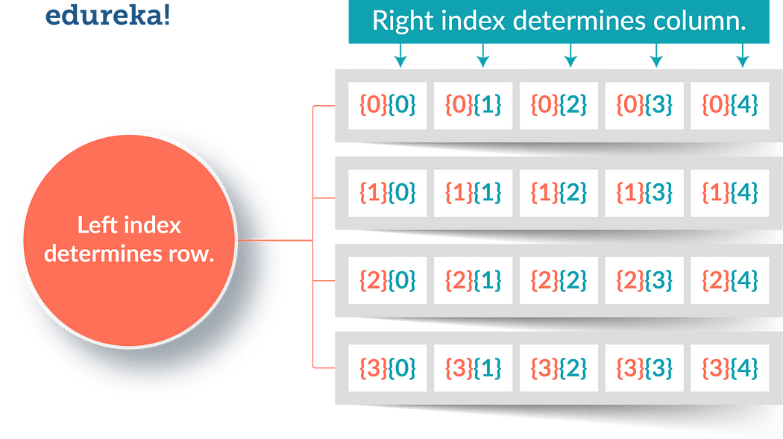

|  |
| --- |
| class Mul2D{  public static void main(String args[]) {  int mul2d[][]= new int[4][5];  int i, j, k = 0;  for(i=0; i&lt;4; i++)  for(j=0; j&lt;5; j++) {  Mul2D[i][j] = k;  k++;  }  for(i=0; i&lt;4; i++) {  for(j=0; j&lt;5; j++);  System.out.print(mul2d[i][j] + " ");  System.out.println();  }  }  } |

**This program generates the following output:**

0 1 2 3 4 5 6 7 8 9 10 11 12 13 14 15 16 17 18 19

These are other Multidimensional arrays representation of other data types.

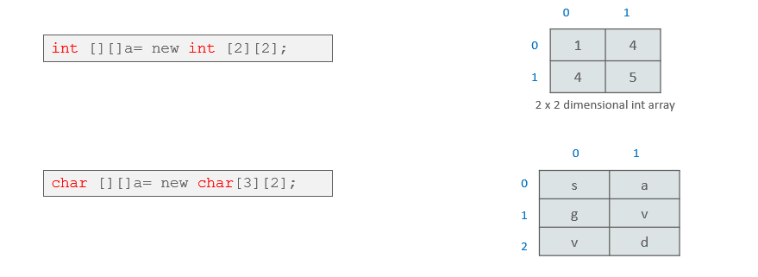

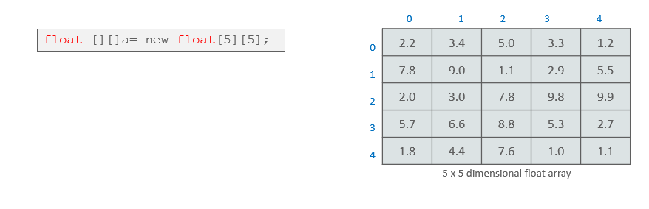

* So, this was all about the Multidimensional Arrays. Now, Let us see, how to pass an array to a method as a parameter like the other data types.

**Passing Java Array to a Method**

* We can also pass arrays to methods just as we can pass primitive type values to methods.

**Example:**

|  |
| --- |
| public class PMethods{  public static void display(int y[])  {  System.out.println(y[0]);  System.out.println(y[1]);  System.out.println(y[2]);    }  public static void main(String args[])  {  int x[] = { 1, 2, 3 };  display(x);  }  } |

This will be the output of the program:

|  |
| --- |
| 1  2  3 |

Java Arrays: (<https://medium.com/@nikhilsalvi011/java-arrays-d3bc832e8292>)

* Normally, an array is a collection of similar type of elements which has contiguous memory location.
* Java Array is an object which contains elements of a similar data type. Additionally, The elements of an array are stored in a contiguous memory location. It is a data structure where we store similar elements. We can store only a fixed set of elements in a Java array.
* Array in Java is index-based, the first element of the array is stored at the 0th index, 2nd element is stored on 1st index and so on.
* Unlike C/C++, we can get the length of the array using the length member. In C/C++, we need to use the **sizeof** operator.
* In Java, array is an object of a dynamically generated class. Java array inherits the Object class, and implements the Serializable as well as Cloneable interfaces. We can store primitive values or objects in an array in Java. Like C/C++, we can also create single dimentional or multidimentional arrays in Java.
* Moreover, Java provides the feature of anonymous arrays which is not available in C/C++.

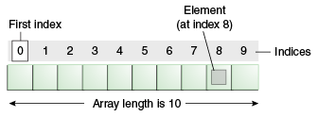

**Advantages:**

* Code Optimization: It makes the code optimized, we can retrieve or sort the data efficiently.
* Random access: We can get any data located at an index position.

**Disadvantages:**

* Size Limit: We can store only the fixed size of elements in the array.
* It doesn’t grow its size at runtime.
* To solve this problem, collection framework is used in Java which grows automatically.

**Types of Array in java:**

There are two types of array.

* Single Dimensional Array
* Multidimensional Array

Single Dimensional Array in Java:

Syntax to Declare an Array in Java

|  |
| --- |
| dataType[] arr; (or)  dataType []arr; (or)  dataType arr[]; |

Instantiation of an Array in Java

|  |
| --- |
| arrayRefVar=new datatype[size]; |

**Example of Java Array :**

Let’s see the simple example of java array, where we are going to declare, instantiate, initialize and traverse an array.

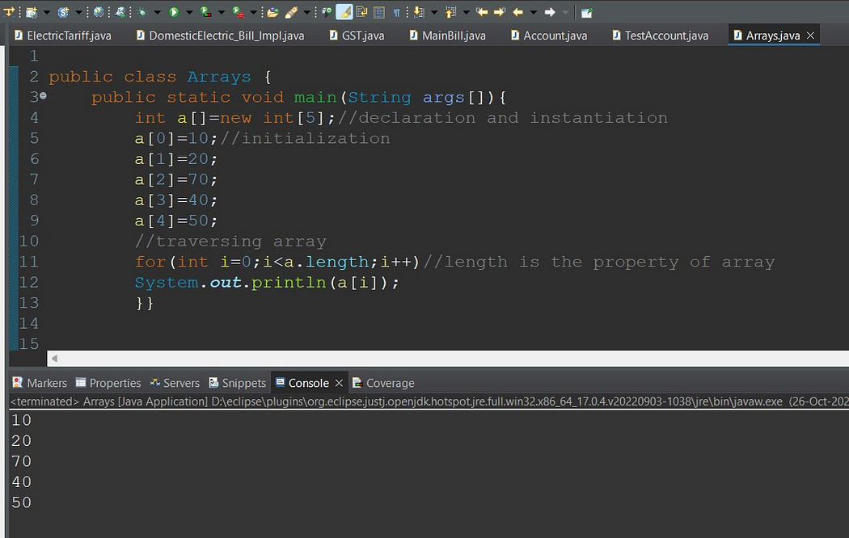

Declaration, Instantiation and Initialization of Java Array:

We can declare, instantiate and initialize the java array together by:

|  |
| --- |
| int a[]={33,3,4,5}; //declaration, instantiation and initialization |

Example to print this array:

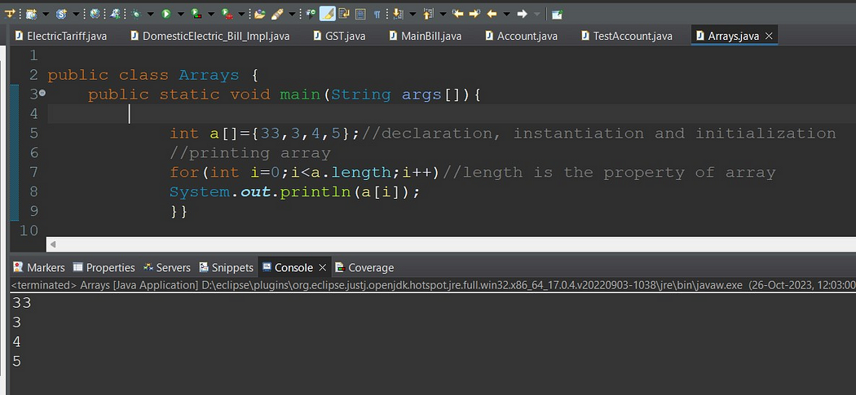

For-each Loop for Java Array:

We can also print the Java array using For-each loop. The Java for-each loop prints the array elements one by one. It holds an array element in a variable, then executes the body of the loop.

The syntax of the for-each loop is given below:

|  |
| --- |
| for(data_type variable:array){  //body of the loop  } |

Example Java array using the for-each loop

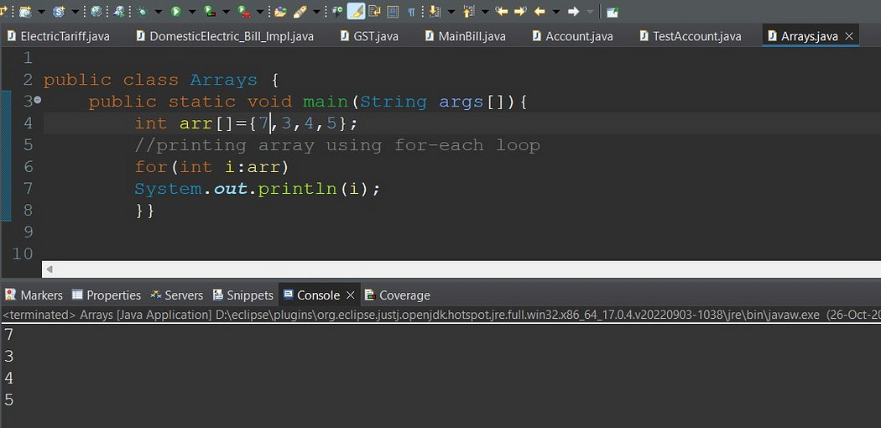

**ArrayIndexOutOfBoundsException** :

The Java Virtual Machine (JVM) throws an ArrayIndexOutOfBoundsException if length of the array in negative, equal to the array size or greater than the array size while traversing the array.

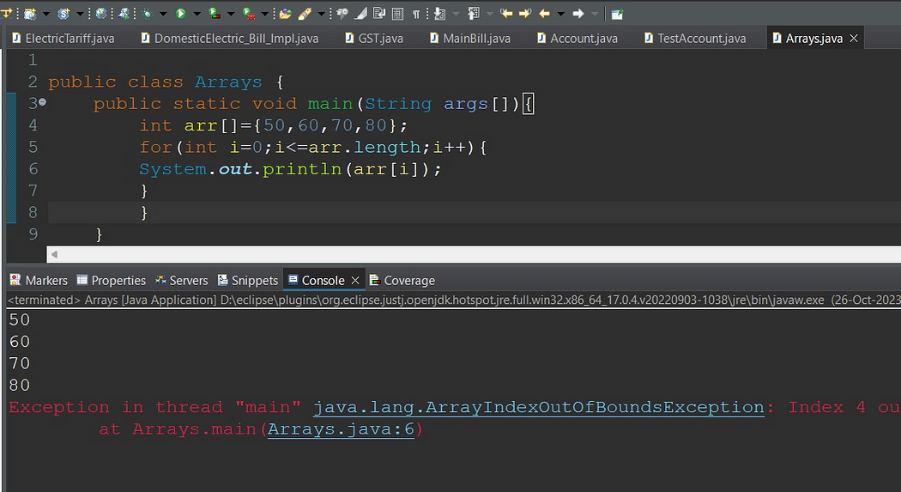

**Multidimensional Array in Java :**

In such case, data is stored in row and column based index (also known as matrix form).

Syntax to Declare Multidimensional Array in Java :

|  |
| --- |
| dataType[][] arrayRefVar; (or)  dataType [][]arrayRefVar; (or)  dataType arrayRefVar[][]; (or)  dataType []arrayRefVar[]; |

Example to instantiate Multidimensional Array in Java:

1. **int[][] arr=new int[3][3];//3 row and 3 column**

Example to initialize Multidimensional Array in Java

|  |
| --- |
| arr[0][0]=1;  arr[0][1]=2;  arr[0][2]=3;  arr[1][0]=4;  arr[1][1]=5;  arr[1][2]=6;  arr[2][0]=7;  arr[2][1]=8;  arr[2][2]=9; |

Example of Multidimensional Java Array :

Let’s see the simple example to declare, instantiate, initialize and print the 2Dimensional array.

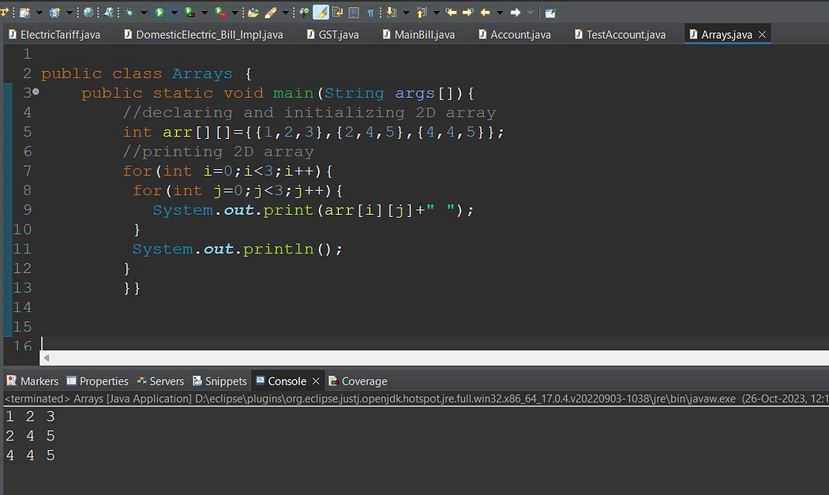

**Copying a Java Array:**

* We can copy an array to another by the arraycopy() method of System class.

**Syntax of arraycopy method**

|  |
| --- |
| public static void arraycopy(Object src, int srcPos,Object dest, int destPos, int length) |

**Example of Copying an Array in Java:**

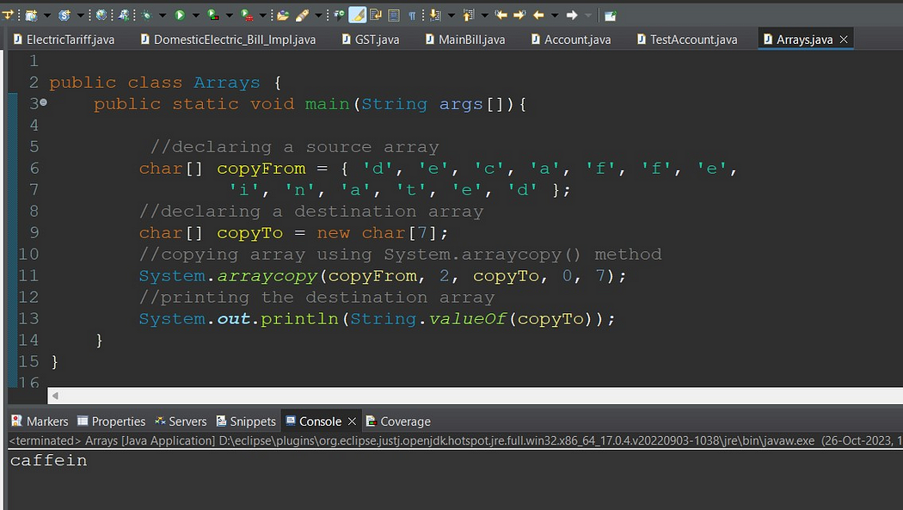

**Addition of 2 Matrices in Java:**

* Let’s see a simple example that adds two matrices.

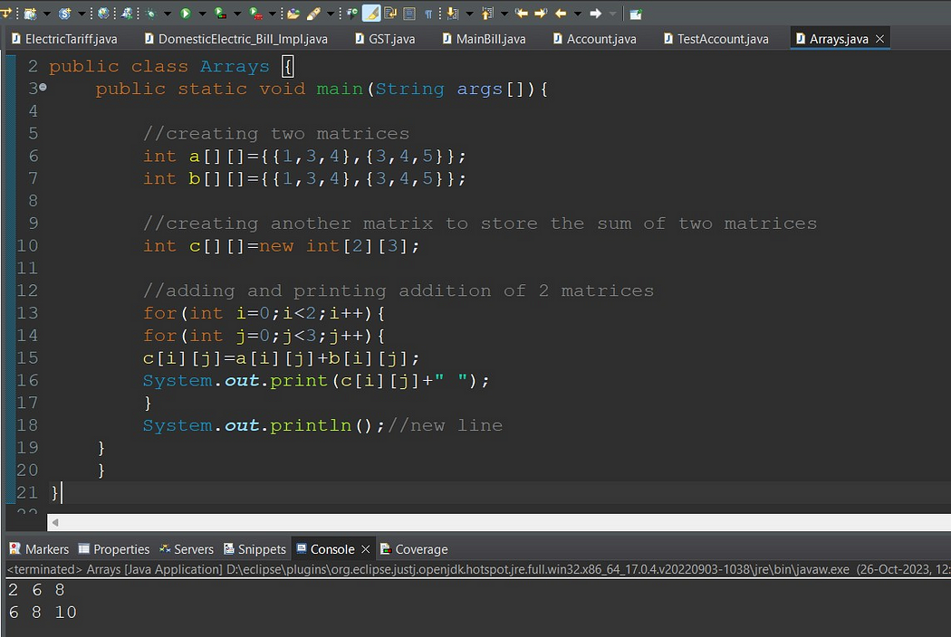

**Multiplication of 2 Matrices in Java:**

In the case of matrix multiplication, a one-row element of the first matrix is multiplied by all the columns of the second matrix which can be understood by the image given below.

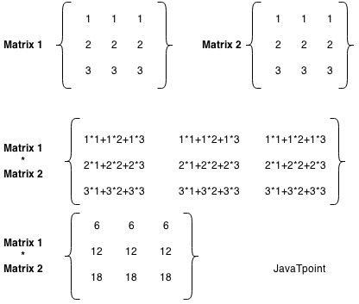

Example to multiply two matrices of 3 rows and 3 columns:

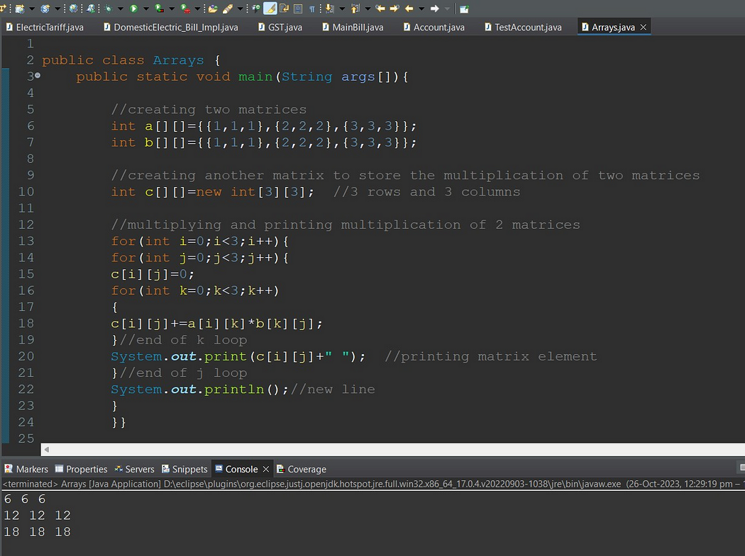

**Different methods for Arrays Operations:**

Basic Array Manipulations in Java

* Sorting Arrays with Arrays.sort():

|  |
| --- |
| String[] fruits = {"Apple", "Cherry", "Banana", "Dragonfruit"};  Arrays.sort(fruits);  for (String fruit : fruits) {  System.out.print(fruit + " ");  }  // Output:  // `Apple Banana Cherry Dragonfruit ` |

**We have many overload methods for Arrays.sort() method and it accepts Comparator instance as well.**

* public static <T> void sort(T[] a, Comparator<? super T> c)
* public static <T> void sort(T[] a, int fromIndex, int toIndex, Comparator<? super T> c)
* Filling Arrays with Arrays.fill()

The Arrays.fill() method is used to fill an entire array with a single value. It can be useful when you want to reset all values in an array or initialize them to a specific value.

|  |
| --- |
| int[] array = new int[5];  Arrays.fill(array, 1);  for (int i : array) {  System.out.print(i + " ");  }  // Output:  // 1 1 1 1 1 |

* Arrays.toString()

The Arrays.toString() method is a simple and effective way to convert an entire array into a string format, which is useful for printing or logging purposes.

|  |
| --- |
| int[] array = {1, 2, 3};  System.out.println(Arrays.toString(array)); |

* Copying Arrays with Arrays.copyOf()

The Arrays.copyOf() method allows you to create a new array that is a copy of an existing array. This method is useful when you want to manipulate an array **without affecting the original data.**

**public static <T,U> T[] copyOfRange(U[] original, int from, int to, Class<? extends T[]> newType)**

|  |
| --- |
| Here’s how to use Arrays.copyOf():  int[] original = {1, 2, 3};  int[] copy = Arrays.copyOf(original, original.length);  System.out.println(Arrays.toString(copy));  // Output:  // [1, 2, 3] |

* Comparing Arrays with Arrays.equals()

The Arrays.equals() method is used to check if two arrays are equal, meaning **their length, order, and elements are the same.**

* We should use the **deepEquals** method when we want to check the equality between two nested or multidimensional arrays. Also, when we want to compare two arrays composed of user-defined objects, as we’ll see later, we must override the equals method.
* By analyzing the method’s internal implementation, we can see that the method not only checks the top-level elements of the arrays but also checks recursively every subelement of it.
* Therefore, we should avoid using the deepEquals method with arrays that have a self-reference because this will result in a java.lang.**StackOverflowError**.

|  |
| --- |
| Plane[][] planes1  = new Plane[][] { new Plane[]{new Plane("Plane 1", "A320")}, new Plane[]{new Plane("Plane 2", "B738") }};  Plane[][] planes2  = new Plane[][] { new Plane[]{new Plane("Plane 1", "A320")}, new Plane[]{new Plane("Plane 2", "B738") }};    System.out.println(Arrays.equals(planes1, planes2));  System.out.println(Arrays.deepEquals(planes1, planes2)); |

|  |
| --- |
| Let’s see it in action:  int[] array1 = {1, 2, 3};  int[] array2 = {1, 2, 3};  boolean isEqual = Arrays.equals(array1, array2);  System.out.println(isEqual);  // Output:  // true |

* Searching in Arrays with Arrays.binarySearch()

The Arrays.binarySearch() method is used to search for a specific element in an array. It uses the binary search algorithm, which is more efficient than a linear search, but requires the array to be sorted first.

|  |
| --- |
| int[] array = {1, 2, 3, 4, 5};  int **index** = Arrays.binarySea**rch(array, 3);**  **System.out.println(index);**  // Output:  // 2 |

In this example, Arrays.binarySearch() returns 2, which is the index of the number 3 in the array.

Arrays.compare(array1,arrays2)

* lexicographical order is alphabetical order. The other type is numerical ordering. Consider the following values,
* 1, 10, 2
* Those values are in lexicographical order. 10 comes after 2 in numerical order, but 10 comes before 2 in "alphabetical" order.
* abc, abb, azc
* abb,abc, azc

|  |
| --- |
| public class ArraysLexicographicallyEqualDemo {  public static void main(String[] args)  {  int array1[]={19,27,55,80};  int array2[]={19,27,55,80};  System.out.println(Arrays.compare(array1,array2));  }    } |

* **Arrays. asList()**

<https://medium.com/@arungupta651/how-to-use-arrays-aslist-in-java-with-examples-732fc6a0e92b>

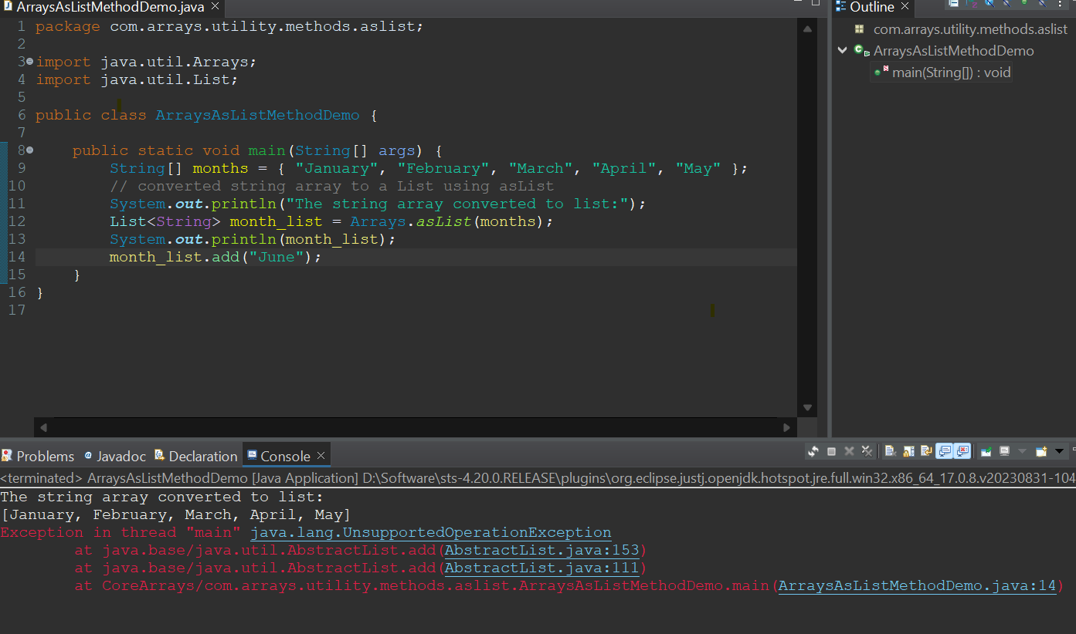

**Exploring Alternative Approaches to Array Manipulation**

* Using ArrayLists for Dynamic Arrays

While Java arrays are powerful, they have a limitation: their size is fixed at the time of creation. To overcome this, we can use ArrayList, a resizable array implementation in the Java Collections Framework.

Here’s how you can create an ArrayList and add elements to it:

|  |
| --- |
| List<Integer> list = new ArrayList<>();  list.add(1);  list.add(2);  list.add(3);  System.out.println(list);  // Output:  // [1, 2, 3] |

Streamlining Array Operations with Java Streams

* Java Streams, introduced in Java 8, provide a powerful and flexible way to process data structures, including arrays.
* With Streams, you can easily perform complex data transformations using functional programming style.
* Here’s an example of using a Stream to filter and transform an array:

|  |
| --- |
| int[] array = {1, 2, 3, 4, 5};  int[] evenSquares = **Arrays.stream(array)**  .filter(n -> n % 2 == 0)  .map(n -> n * n)  .toArray();  System.out.println(Arrays.**toString**(evenSquares));  // Output:  // [4, 16] |

* In this example, we start with an array of numbers. We create a Stream from the array, filter out the odd numbers, square the remaining even numbers, and collect the results back into a new array.
* Streams provide a powerful and expressive way to manipulate arrays in Java.

Troubleshooting Common Issues with Java Array Methods:

* Handling ArrayIndexOutOfBoundsException

One common issue when working with arrays is the ArrayIndexOutOfBoundsException. This exception is thrown to indicate that you’ve attempted to access an array with an illegal index, either negative or greater than the array’s size.

Here’s a simple example of an **ArrayIndexOutOfBoundsException**:

|  |
| --- |
| int[] array = {1, 2, 3};  try {  System.out.println(array[3]);  } catch (ArrayIndexOutOfBoundsException e) {  e.printStackTrace();  }  // Output:  // java.lang.ArrayIndexOutOfBoundsException: Index 3 out of bounds for length 3  Java  In this example, we try to access array[3], which doesn’t exist because our array’s length is 3 and array indices start at 0. To avoid this exception, always ensure your index is within the array’s bounds. |

Dealing with Null Values in Arrays:

Another common issue is d**ealing with null values in arrays. If you attempt to call a method on a null value, a NullPointerException** will be thrown.

Here’s an example:

|  |
| --- |
| Integer[] **array = {1, null, 3};**  try {  System.out.println(array[1].toString());  } catch (NullPointerException e) {  e.printStackTrace();  }  // Output:  // java.lang.**NullPointerException**  Java  In this example, we attempt to call toString() on a null value, which results in a NullPointerException. To avoid this, always check if an array element is null before attempting to call methods on it. |

**Collections Framework Overview:**

* <https://hansinirup.medium.com/collections-framework-in-java-7f2d13dca075>
* <https://medium.com/javarevisited/getting-started-with-collection-framework-part-1-f2b546adcf29>

Need for Collection Framework:

Let’s suppose, you want to represent huge number of values then using separate variable for each value is not a good programming practice. Hence, to overcome this problem, we can go for Array concept.

Array

An Array is an indexed collection of fixed number of homogeneous data elements. The main advantage of arrays is, we can represent multiple values by using single variable. So that readability of code will be improved.

**Limitations of Arrays:**

* Arrays are fixed in size i.e. Once we create an array, there is no chance of increasing or decreasing the size based on our requirement.
* Due to this, to use the arrays concept, compulsory we should know the size in advance, which may not be possible always.
* Array can hold only homogeneous data type elements.

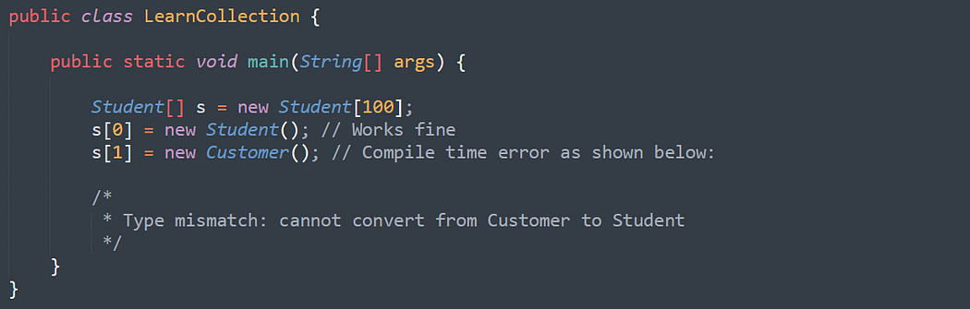

However, we can solve this problem by using Object type arrays.

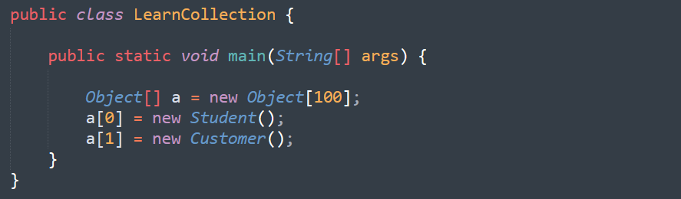

* Arrays concept is not implemented based on some standard data structure and hence readymade method support is not available. For every requirement, we have to write the code explicitly. Which increases complexity of programming.

To overcome above problems of Array, we should go for “Collection” concept.

* Collections are growable in nature i.e. based on our requirement we can increase/decrease the size.
* Collections can hold both homogeneous and heterogeneous elements.
* Every collection class is implemented based on some standard data structure. Hence for every requirement readymade method support is available.

|  |
| --- |
| Being a programmer, we are responsible to use those methods and we are not responsible to implement those methods. |

**What is the difference between Array and Collection:**

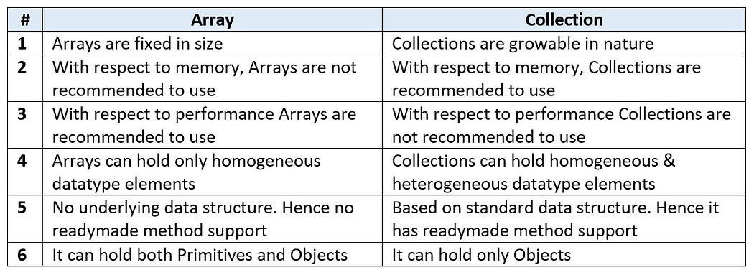

**Collections**

* Collections are the containers that group multiple items into a single unit.
* Collections are used to store, retrieve and manipulate data and to transmit data from one method to another.

**Java Collections Framework**

* A collections framework is a unified architecture for representing and manipulating collections.
* Java Collections framework provides many interfaces and classes in order to store data.

**Benefits of a Collections Framework**

* It reduces programming effort.
* It increases program speed and quality.
* It allows interoperability among unrelated APIs.
* It fosters software reuse.
* It reduces effort to design new APIs.

**Java Collections Framework Hierarchy**

* A set of APIs linked together as a parent-child relationship.

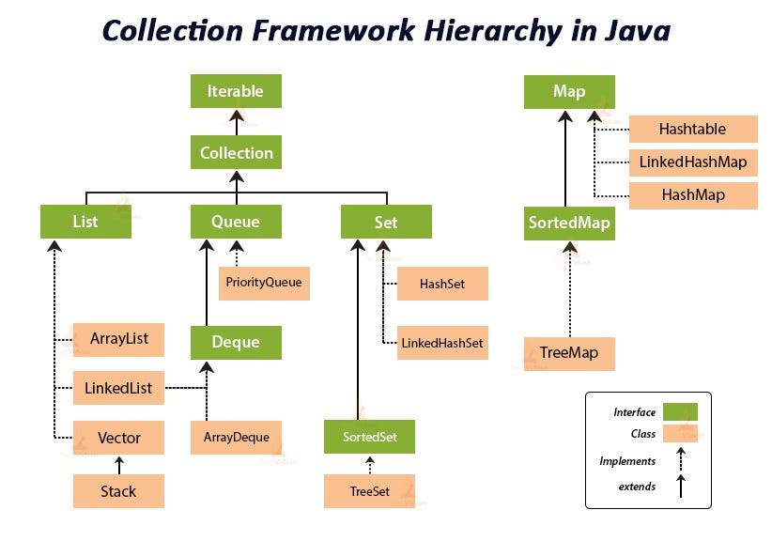

**Java Interfaces**

* In interfaces in Java, you write methods which must be implemented by Java objects as rules.
* Interfaces are the reference types which are similar to classes but contains only abstract methods as rules.

1. **Iterable**

* The Iterable interface is the root interface for all the Collection classes.
* The Collection interface along with all its subclasses also implement the Iterable interface.
* The Iterable interface is a core part of Java and is used for enabling objects to be the target of the 'for-each loop' statement. It is present in the java. lang package, and any class implementing this interface allows its objects to be iterated using the enhanced for loop.

**Methods: Iterator <T> iterator()**

* From the above method, we get reference of Iterator and we can iterate in the forward direction in any data structure.
* 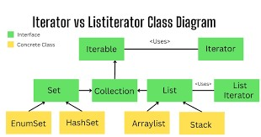

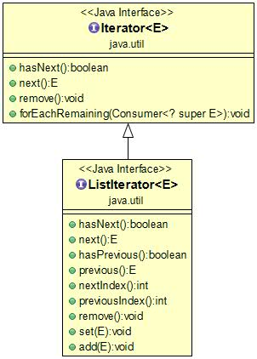

A Java Cursor is an Iterator, which is used to **iterate or traverse or retrieve a Collection or Stream object's elements one by one.**

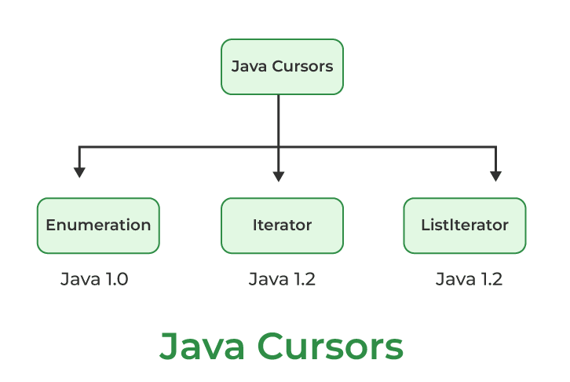

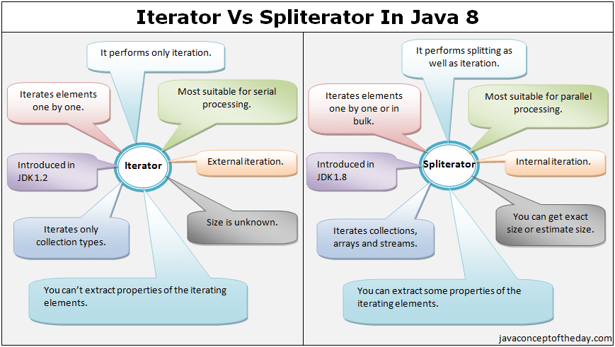

**Iterator and Iterable difference:**

**Difference between iterator and iterable** - iterable will give capability of looping feature of any custom class and Iterator will take the collection instance and point single element and will give you the (hasNext(), next() and remove() ) feature on the **collection data structure.**

* The Iterable interface is a core part of Java and is used for enabling objects to be the target of **the 'for-each loop' statement**. It is present in the **java.lang** package, and any class implementing this interface allows its objects to be iterated using the **enhanced for loop.**

**Example:**

|  |
| --- |
| package com.collections.iterable;  import java.util.ArrayList;  import java.util.Arrays;  import java.util.Iterator;  import java.util.List;  public class CustomIterable<T> implements Iterable<T> {  List<T> values = new ArrayList<>();  public void add(T value) {  values.add(value);  }  @Override  public Iterator<T> iterator() {  return new CustomIterator<T>(values);  }  public class CustomIterator<E> implements Iterator<E> {  List<E> data;  int position = 0;  public CustomIterator(List<E> data) {  this.data = data;  }  @Override  public boolean hasNext() {  System.out.println("Hasnext called position: "+ position);  System.out.println("data.size() > position + 1" + (data.size() > position + 1));  return data.size() > position + 1;  }  @Override  public E next() {  E nextValue = this.data.get(position);  position++;  System.out.println("next method caleld and value is : " + nextValue.toString());  return nextValue;  }  }  public static void main(String[] args) {  CustomIterable<Integer> integers = new CustomIterable<>();  integers.add(1);  integers.add(2);  integers.add(3);  integers.add(4);  integers.add(5);  for (Integer integer : integers)  System.out.println("In main method" + integer);    List<String> names = Arrays.asList("A","B","C")    }  } |

1. **Collection**

* Collection interface is implemented by all the classes in the collection framework and declares the methods that every collection contain.
* This achieves Runtime Polymorphism.

**Methods: Boolean add (Object obj)**

* Boolean addAll (Object obj)
* void clear() , etc.

**Difference between traditional for loop and enhanced for loop:**

**traditional for loop:**

* Using this for loop we can iterate on any container object.
* **Using this for loop we can iterate on any container object.**
* This for-loop is present from JDK1
* In a normal for-loop, we can increase the counter as per our wish by using

i=i+x( where x is any constant x=1,2,3…)

* Using this for loop we can iterate on any container object.
* In this for-loop, we can iterate in both decrement or increment order.
* In this for-loop, we can replace elements at any specific index.
* By using normal for-loop we can print array elements either in the original order or in reverse order.

|  |
| --- |
| **Example: Printing element in a 1D array**  int[ ] x={1,2,3};  for(int i=0;i<x.length;i++)  {  System.out.println(x[i]);  }  **Example: Printing element in a 2D array using for loop**  int[ ][ ] x={{1,2,3},{4,5,6}};  for(int i=0;i<x.length;i++) {  for(int j=0; j<x[i].length;j++) {  System.out.println(x[i][j]);  }  } |

**Enhanced For Loop(Advance for loop):**

* This for loop is present from JDK5
* But enhanced for loop will execute in a sequential manner i.e counter will always increase by one.
* **We can only iterate on that container by using this loop to implement the iterable interface.**
* But in this for-loop, we can iterate only in increment order.
* But in this for-loop, we don’t have access to the index, so we cannot replace elements at any specific index.
* But in the for-each loop, we can print array element only in the original order, not in reverse order.

|  |
| --- |
| **Example: Printing element in a 1D array using for-each loop**  int[ ] x={1,2,3};  for(int a : x)  {  System.out.println(a);  }  **Example: Printing element in a 2D array using for-each loop**  int[ ][ ] x={{1,2,3},{4,5,6}} ;  for(int[ ] x1 :x){  for(int x2 : x1) {  System.out.println(x2);}  } |

**Exmaple 1:**

|  |
| --- |
| for(String s : list) {  System.out.println("s" + s);  list.remove(0);  }  **Note**: In advanced for loop, we can not use iterator directly. We can use data source collection and we have remove method by passing ides or object. Once you modify the structure during looping time we will get Concurrent modification exception. |

**Reference link :**

<https://anmolsehgal.medium.com/fail-fast-and-fail-safe-iterations-in-java-collections-11ce8ca4180e>

**Fail-fast and Fail-safe iterations in Java Collections:**

* Using iterations we can traverse over the collections objects. The iterators can be either fail-safe or fail-fast.
* Fail-safe iterators means they will not throw any exception even if the collection is modified while iterating over it.
* Whereas Fail-fast iterators throw an exception(**ConcurrentModificationException**) if the collection is modified while iterating over it.

Consider an example:

|  |
| --- |
| ArrayList<Integer> integers = new ArrayList<>();  integers.add(1);  integers.add(2);  integers.add(3);  Iterator<Integer> itr = integers.iterator();  while (itr.hasNext()) {  Integer a = itr.next();  integers.remove(a);  } |

**Explanation:**

* As arrayLists are fail-fast above code will throw an exception.
* First a will have value = 1, and then 1 will be removed in same iteration.
* Next when a will try to **get next(),** as the modification is made to the list, it will throw an exception here.

However if we use an fail-safe collection e.g. **CopyOnWriteArrayList** then no exception will occur:

|  |
| --- |
| List<Integer> integers = new CopyOnWriteArrayList<>();  integers.add(1);  integers.add(2);  integers.add(3);  Iterator<Integer> itr = integers.iterator();  while (itr.hasNext()) {  Integer a = itr.next();  integers.remove(a);  }  Here if we print the element a, then all the elements will be printed. |

**Fail-Fast Iterators internal working:**

* Every fail fast collection has a **modCount** field, to represent how many times the collection has **changed/modified.**
* So at every modification of this collection we increment the **modCount** value. For example the modCount is incremented in below cases:

1. When one or more elements are removed.

2. When one or more elements are added.

3. When the collection is replaced with other collection.

4. When the collection is sorted.

* So everytime there is some change in the collection structure, the mod count is incremented.

**Important Points:**

* Now the iterator stores the **modCount** value in the initialization as below:

|  |
| --- |
| int expectedModCount = modCount; |

* Now while the iteration is going on, expectedModCount will have old value of modCount.
* If there is any change made in the collection, the modCOunt will change and then an exception is thrown using:

|  |
| --- |
| if (modCount != expectedModCount)  throw new ConcurrentModificationException(); |

This code is used in most of the iterator methods e.g.

1. next()

2. remove()

So if we make any changes to the collection, the modCount will change, and expectedModCount will not be hence equal to the modCount. Then if we use any of the above methods of iterator, the ConcurrentModificationException will be thrown.

**Note**: If we remove/**add** the element using the remove() or add() of iterator instead of collection, then in that case no exception will opccur. It is because the remove/**add** methods of iterators call the remove/add method of collection internally, and also it reasigns the expectedModCount to new modCount value.

|  |
| --- |
| ArrayList.this.remove(lastRet);  cursor = lastRet;  lastRet = -1;  expectedModCount = modCount;  and  ArrayList.this.add(i, e);  expectedModCount = modCount; |

So the below code is safe as we are removing the element from the iterator here:

|  |
| --- |
| Iterator<Integer> itr = integers.iterator();  while (itr.hasNext()) {  if (itr.next() == 2) {  // will not throw Exception  itr.remove();  }  } |

Whereas the below code will throw an exception as we are removing the element from the collection here.

|  |
| --- |
| Iterator<Integer> itr = integers.iterator();  while (itr.hasNext()) {  if (itr.next() == 3) {  // will throw Exception on  // next call of next() method  integers.remove(3);  }  } |

**Fail-Safe Iterators internal working:**

* Unlike the fail-fast iterators, these iterators traverse over the clone of the collection. So even if the original collection gets structurally modified, no exception will be thrown.
* E.g. in case of CopyOnWriteArrayList the original collections is passed and is stored in the iterator:

|  |
| --- |
| public Iterator<E> iterator() {  return new COWIterator<E>(getArray(), 0);  } |

here iterator() method returns the iterator of the **CopyOnWriteArrayList**. As we can see, it passes the getArray() in the constructor of the iterator. This getArray() has all the collection elements.

Now the iterator(**COWIterator** here) will save this to traverse upon as:

|  |
| --- |
| COWIterator(Object[] elements, int initialCursor) {  cursor = initialCursor;  **snapshot** = elements;  } |

**So the original collection elements are saved in the snapshot field variable.**

So all the iterator methods will work on this snapshot method. So even if there is any change in the original collection, no exception will be thrown. But note the the iterator will not reflect the latest state of the collection.

Iterator<Integer> itr = integers.iterator();

while (itr.hasNext()) {

int a = itr.next();

if (a == 1) {

integers.remove(Integer.valueOf(a));

}

System.out.print(a);

}

So as we are removing the element from the collection. the collection now has only elements 2 and 3 in it. But the iterator will print all the elements 1,2,3 because it traverses over the snapshot of the collection elements.

We can print the collection elements after the above code. It will print only 2,3 as:

Iterator<Integer> itr = integers.iterator();

while (itr.hasNext()) {

int a = itr.next();

System.out.print(a);

}

**Note**: although it does not throw any exception, but the downsides of this iterator are:

1. They will not reflect the latest state of the collection.

2. It requires extra memory as it clones the collection.

**List Interface Overview:**

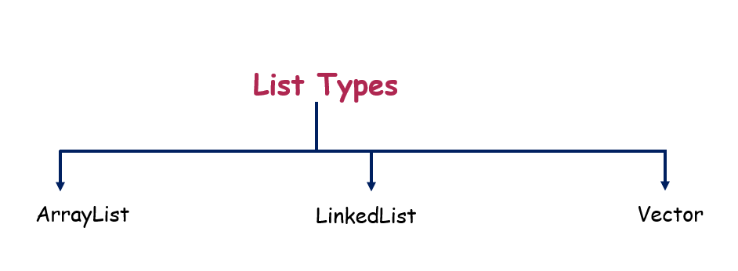

Traditional loop and

**ArrayList**:

<https://medium.com/@reetesh043/java-collection-arraylist-a1a830864e81>

**Create ArrayList through Constructor:**

The core data structure of ArrayList is an array that holds the elements. When we create an ArrayList, it creates an internal array of a certain initial capacity. By default, the initial capacity is **10**, but we can specify a different capacity in the **constructor**.

|  |
| --- |
| // Default initial capacity.  private static final int DEFAULT_CAPACITY = 10;  /**  * The array buffer into which the elements of the ArrayList are stored.  */  transient Object[] elementData; |

* ArrayList is a part of collection framework and is present in java.util package. It provides us dynamic arrays in Java.
* Though, it may be slower than standard arrays but can be helpful in programs where lots of manipulation in the array is needed.
* ArrayList inherits AbstractList class and implements List interface.
* ArrayList is initialized by a size, however the size can increase if collection grows or shrink if objects are removed from the collection.
* Java ArrayList allows us to randomly access the list.
* ArrayList can not be used for primitive types, like int, char, etc. We need a wrapper class for such cases (see this for details).
* ArrayList in Java can be seen as similar to vector in C++.

Must know about array list and how it works internally?

create arrayList()? What is happening?

1. **How to Create arrayList and how it created internally?**

Reference Link - [**https://www.geeksforgeeks.org/internal-working-of-arraylist-in-java/**](https://www.geeksforgeeks.org/internal-working-of-arraylist-in-java/)

* ArrayList is a resizable array implementation in Java. ArrayList grows dynamically and ensures that there is always a space to add elements.
* The backing data structure of ArrayList is an array of Object classes. ArrayList class in Java has 3 constructors. It has its own version of readObject and writeObject methods.
* Object Array in ArrayList is transient. It implements RandomAccess, Cloneable, and java.io.Serializable (which are Marker Interface in Java)

|  |  |  |
| --- | --- | --- |
| public ArrayList() {  this.elementData = DEFAULTCAPACITY_EMPTY_ELEMENTDATA;  } | public ArrayList(int initialCapacity) { | public ArrayList(Collection<? extends E> c) |

Syntax:

public class ArrayList<E>

extends AbstractList<E>

implements List<E>, RandomAccess, Cloneable, java.io.Serializable

Internally an ArrayList uses an Object[] Array which is an array of objects. All operation like deleting, adding, and updating the elements happens in this Object[] array.

/**

* The array buffer into which the elements of the ArrayList are stored.

* The capacity of the ArrayList is the length of this array buffer. Any

* empty ArrayList with elementData == DEFAULTCAPACITY_EMPTY_ELEMENTDATA

* will be expanded to DEFAULT_CAPACITY when the first element is added.

*/

|  |
| --- |
| **transient Object[] elementData; // non-private to simplify nested class access** |

* The above code is from Java 8 in Java 7 the array is declared as a Private transient Object but in Java 8 it’s not Private because non-private is to simplify access for a nested class like Itr, ListItr, SubList.

Initialization

List<String> arrayList = new ArrayList<String>();

while declaring ArrayList below code is executed as the default constructor of the ArrayList class is invoked.

**In Java 7**

public ArrayList() {

this(10);

}

Hereby default capacity of the Array size is 10.

**In Java 8**

|  |
| --- |
| private static final int DEFAULT_CAPACITY = 10;\\ Default initial capacity.    // Shared empty array instance used for empty instances.  private static final Object[] EMPTY_ELEMENTDATA = {};  /**  * Shared empty array instance used for default sized empty instances. We  * distinguish this from EMPTY_ELEMENTDATA to know how much to inflate when  * first element is added.  */ |

Here, the List is initialized with a default capacity of 10. Array List with elementData == DEFAULTCAPACITY_EMPTY_ELEMENTDATA will be expanded to DEFAULT_CAPACITY when the first element is inserted into the Array list ( Adding 1st element to ArrayList).

private static final Object[] DEFAULTCAPACITY_EMPTY_ELEMENTDATA = {};

**Example:**

|  |
| --- |
| import java.util.ArrayList;  import java.util.Collection;    public class Main {  public static void main(String args[])  {  Collection<Integer> arr = new ArrayList<Integer>();  arr.add(1);  arr.add(2);  arr.add(3);  arr.add(4);  arr.add(5);  System.out.println("This is arr " + arr);    ArrayList<Integer> newList  = new ArrayList<Integer>(arr);    System.out.println("This is newList " + newList);  newList.add(7);  newList.add(700);    System.out.println(  "This is newList after adding elements "  + newList);  }  }  **Output**  This is arr [1, 2, 3, 4, 5]  This is newList [1, 2, 3, 4, 5]  This is newList after adding elements [1, 2, 3, 4, 5, 7, 700] |

* Here the elements in the arr are passed to newList. So elements of arr were copied to newList this is shown in the above example.
* How the size of ArrayList grows dynamically? [add() method]

Let’s deep dive into how to add method that works in Array list with help of the internal Java 8 code of ArrayList.

If we try to add an element using the add() method in the array list Internally then it checks for the capacity to store the new element or not, If not then the new capacity is calculated as shown in the internal code of the add() method.

**add() method works:** we have two methods

* add(int index, E obj)
* add(E obj)

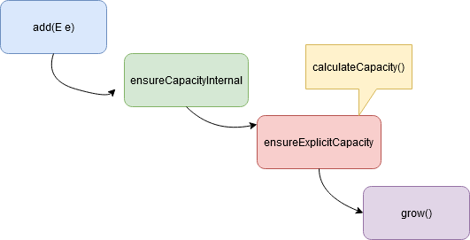

|  |
| --- |
| public boolean add(E e) {  ensureCapacityInternal(size + 1); // Size Increments  elementData[size++] = e;  return true;  } |

Explanation:

* Here in the add(Object ) method object is passed and the size is increased. Internal capacity of the array is ensured by the ensureCapacityInternal() method

|  |
| --- |
| private void ensureCapacityInternal(int minCapacity) {  if (elementData == DEFAULTCAPACITY_EMPTY_ELEMENTDATA) {  minCapacity = Math.max(DEFAULT_CAPACITY, minCapacity);  }  ensureExplicitCapacity(minCapacity);  } |

* This ensureExplicitCapacity method determines what is the current size of elements and what is the maximum size of the array. here Minimum capacity will be the maximum of default capacity and mincapacity then goes for ensureExplicitCapacity method mincapacity as an argument.

|  |
| --- |
| private void ensureExplicitCapacity(int minCapacity) {  modCount++;    // overflow-conscious code  if (minCapacity - elementData.length > 0)  grow(minCapacity);  } |

* Here if the (mincapacity – arraylength) is greater than 0(>0) then the Array size will grow by calling the grow() method and mincapacity as the argument passed.

|  |
| --- |
| /**  * Increases the capacity to ensure that it can hold at least the  * number of elements specified by the minimum capacity argument.  *  * @param minCapacity the desired minimum capacity  */  private void grow(int minCapacity) {  // overflow-conscious code  int oldCapacity = elementData.length;  **int newCapacity = oldCapacity + (oldCapacity >> 1);**  if (newCapacity - minCapacity < 0)  newCapacity = minCapacity;  if (newCapacity - MAX_ARRAY_SIZE > 0)  newCapacity = hugeCapacity(minCapacity);  // minCapacity is usually close to size, so this is a win:  elementData = Arrays.copyOf(elementData, newCapacity);  } |

* The grow method in the ArrayList class gives the new size array. In Java 8 and later The new capacity is calculated which is 50% more than the old capacity and the array is increased by that capacity. It uses **Arrays.copyOf** which gives the array increased to the new length by right shift operator also it will grow by 50% of old capacity.

|  |
| --- |
| int newCapacity = oldCapacity + (oldCapacity >> 1); |

* For example, if the Array size is 10 and already all the rooms were filled by the elements, while we are adding a new element now the array capacity will be increased as **10+ (10>>1) => 10+ 5 => 15.** Here the size is increased from **10 to 15**. To increase the size by 50% we use the right shift operator. While in Java 6 it’s totally different from the ab**ove calculation on increasing the size of the Array, in java 6 the capacity increases by the amount to 1.5X**

|  |
| --- |
| int newCapacity = (oldCapacity * 3)/2 + 1; -- Java 6 |

**How does the remove method work in ArrayList? [ArrayList shrinks automatically]**

* To remove an element from ArrayList in Java , we can use either **remove(int i)** [0 index based] or remove(Object o) .
* while removing any element from an ArrayList, internally all the subsequent elements are to be shifted left to fill the gap created by the removed element in the array then subtracts one from their indices.
* size of the array will be decreased by 1 ( – – size).

|  |
| --- |
| // Removes the element at the specified position in this list.  // Shifts any subsequent elements to the left (subtracts one from their indices).  public E **remove**(int index) {  rangeCheck(index);  **modCount**++;  E **oldValue** = elementData(index);  int numMoved = size - index - 1;  if (numMoved > 0)  **System.arraycopy**(elementData, index+1, elementData, index, numMoved);  **elementData**[--size] = null; // clear to let GC do its work  return oldValue;  } |

* **System.arrayCopy** method is used for this purpose. Here **index+1** is the initial position and index is the final position.
* Since the element at the position index is removed so elements starting from index+1 are copied to the destination starting from the **index**.

|  |
| --- |
| System.arraycopy(elementData, index+1, elementData, index, numMoved);  **This is how ArrayList shrinks automatically.//** |

**Best practices in creating ArrayList**

* Whenever an ArrayList exceeds the capacity of the internal array it creates a new internal array with 50% more capacity and copies all old elements from the old array to the new one. Repeated resizes will add load for memory allocation and garbage collection and the time to do the copy.
* If you have a clear idea of the eventual size of your ArrayList it is best to pass that size as the initialCapacity to the ArrayList constructor.
* However if you are copying another collection into the list it is better to pass that collection into the ArrayList constructor.

Performance of ArrayList :

The time complexity of the common operations in ArrayList java.

1. add(): For adding a single element O(1) . Adding n element in the array list takes O(n).
2. add(index, element): adding element in particular index in average runs in O(n) time.
3. get(): is always a constant time O(1) operation.
4. remove(): runs in linear O(n) time. We have to iterate the entire array to find the element fit for removal.
5. indexOf(): It runs over the whole array and iterates through each and every element worst case will be the size of the array n .so, it requires O(n) time.
6. contains(): implementation is based on indexOf(). So it will also run in O(n) time.
7. The size, isEmpty, set, iterator, and listIterator operations run in constant time O(1)

**Note:**

1. ArrayList is a resizable array implementation in java.
2. The backing data structure of ArrayList is an array of Object class.
3. When creating an ArrayList you can provide initial capacity then the array is declared with the given capacity.
4. The default capacity value is 10. If the initial capacity is not specified by the user then the default capacity is used to create an array of objects.
5. When an element is added to an ArrayList it first checks whether the new element has room to fill or it needs to grow the size of the internal array, If capacity has to be increased then the new capacity is calculated which is 50% more than the old capacity and the array is increased by that capacity.

### Methods of ArrayList in java:

|  |  |
| --- | --- |
| **Method** | **Description** |
| void [add](https://www.javatpoint.com/java-arraylist-add-method)(int index, E element) | It is used to insert the specified element at the specified position in a list. |
| boolean [add](https://www.javatpoint.com/java-arraylist-add-method)(E e) | It is used to append the specified element at the end of a list. |
| boolean [addAll](https://www.javatpoint.com/java-arraylist-addall-method)(Collection<? extends E> c) | It is used to append all of the elements in the specified collection to the end of this list, in the order that they are returned by the specified collection's iterator. |
| boolean [addAll](https://www.javatpoint.com/java-arraylist-addall-method)(int index, Collection<? extends E> c) | It is used to append all the elements in the specified collection, starting at the specified position of the list. |
| void [clear](https://www.javatpoint.com/java-arraylist-clear-method)() | It is used to remove all of the elements from this list. |
| void ensureCapacity(int requiredCapacity) | It is used to enhance the capacity of an ArrayList instance. |
| E get(int index) | It is used to fetch the element from the particular position of the list. |
| boolean isEmpty() | It returns true if the list is empty, otherwise false. |
| [Iterator()](https://www.javatpoint.com/java-arraylist-iterator-method) |  |
| [listIterator()](https://www.javatpoint.com/java-arraylist-listiterator-method) |  |
| int lastIndexOf(Object o) | It is used to return the index in this list of the last occurrence of the specified element, or -1 if the list does not contain this element. |
| Object[] toArray() | It is used to return an array containing all of the elements in this list in the correct order. |
| <T> T[] toArray(T[] a) | It is used to return an array containing all of the elements in this list in the correct order. |
| Object clone() | It is used to return a shallow copy of an ArrayList. |
| boolean contains(Object o) | It returns true if the list contains the specified element. |
| int indexOf(Object o) | It is used to return the index in this list of the first occurrence of the specified element, or -1 if the List does not contain this element. |
| E remove(int index) | It is used to remove the element present at the specified position in the list. |
| boolean [remove](https://www.javatpoint.com/java-arraylist-remove-method)(Object o) | It is used to remove the first occurrence of the specified element. |
| boolean [removeAll](https://www.javatpoint.com/java-arraylist-removeall-method)(Collection<?> c) | It is used to remove all the elements from the list. |
| boolean removeIf(Predicate<? super E> filter) | It is used to remove all the elements from the list that satisfies the given predicate. |
| protected void [removeRange](https://www.javatpoint.com/java-arraylist-removerange-method)(int fromIndex, int toIndex) | It is used to remove all the elements lies within the given range. |
| void replaceAll(UnaryOperator<E> operator) | It is used to replace all the elements from the list with the specified element. |
| void [retainAll](https://www.javatpoint.com/java-arraylist-retainall-method)(Collection<?> c) | It is used to retain all the elements in the list that are present in the specified collection. |
| E set(int index, E element) | It is used to replace the specified element in the list, present at the specified position. |
| void sort(Comparator<? super E> c) | It is used to sort the elements of the list on the basis of the specified comparator. |
| Spliterator<E> spliterator() | It is used to create a spliterator over the elements in a list. |
| List<E> subList(int fromIndex, int toIndex) | It is used to fetch all the elements that lies within the given range. |
| int size() | It is used to return the number of elements present in the list. |
| void trimToSize() | It is used to trim the capacity of this ArrayList instance to be the list's current size. |

**How index based mechanism will work in java:**

<https://www.codecademy.com/article/sql-indexes>

**Database Indexing In A Nutshell**

Indexing is a performance-tuning method of allowing faster retrieval of records. An index creates an entry point for each value in indexed column(s).

|  |
| --- |
| element address = (base address) + (element index * size of a single element) |

**Base address :** It is the address of the element at the index 0 or the location of the first element of the array in the memory.. The compiler knows this address as the memory location of the array.

**Element index :** It is the sequential number (index/key) assigned to the element where the first element of the array is assigned 0. It can also be defined as the number of elements prior to that particular element in the array.

**Size of a single element :** Elements in the array need to be of the same data type or object. The size of the single element is the number of bytes required in memory to store a single element of that kind.

**Linked List Data Structure:**